", View::POS_READY);

?>

<h1>Product</h1>

<?php if (Yii::$app->session->hasFlash('success')): ?>

<div class="alert alert-success"><?= Yii::$app->session->getFlash('success'); ? ></div>

<?php endif; ?>

<?php $form = ActiveForm::begin(); ?>

<?= $form->field($model, 'title')->textInput() ?>

<?= $form->field($model, 'category_id')->dropDownList(ArrayHelper::map(

Category::find()->where('category_id IS NULL')->asArray()->all(),'id', 'title'), [

'prompt' => 'Select a category',

'onChange' => 'categoryOnChange($(this).val());',

]) ?>

<?= $form->field($model, 'sub_category_id')->dropDownList(

ArrayHelper::map(Category::getSubCategories($model->sub_category_id), 'id'

, 'title'), [

'prompt' => 'Select a sub category',

]) ?>

<div class="form-group">

<?= Html::submitButton('Submit', ['class' => 'btn btn-primary']) ?>

</div>

<?php ActiveForm::end(); ?>

3. Run the dropdown controller by opening index.php?r=dropdown, then add a new product with the value Canon - eos Rebel T6i dslr for the title field:

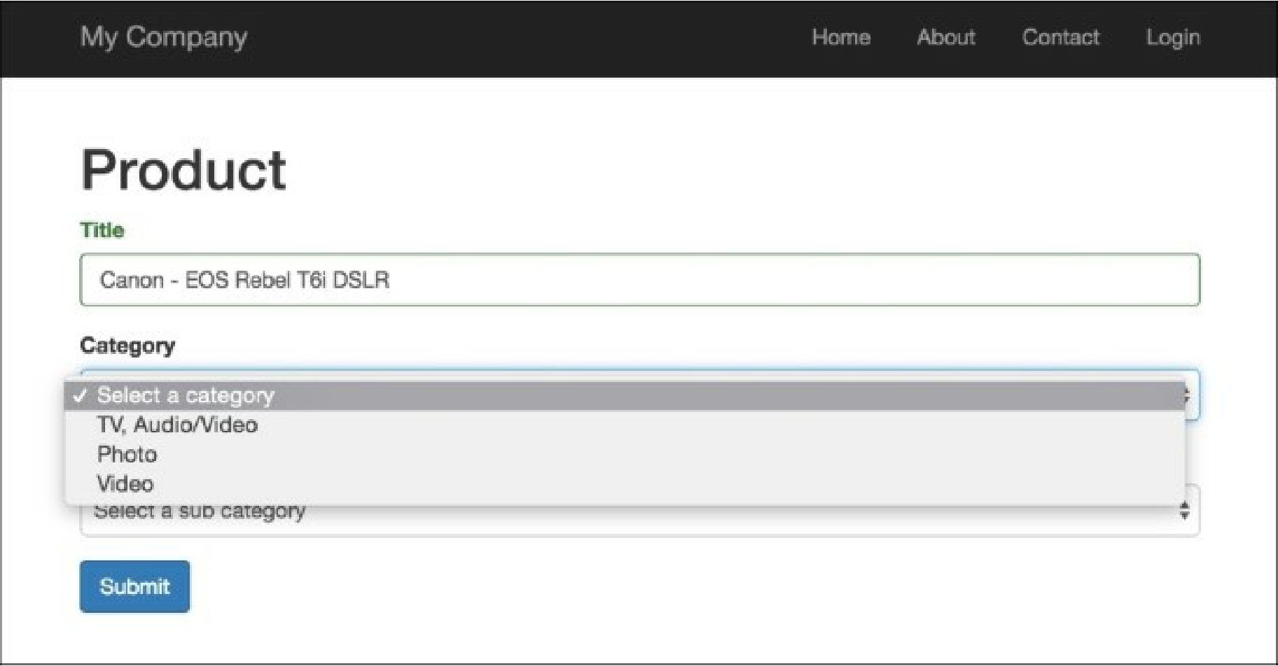

4. As you can see, the Category input has three options. Let’s select the Photo option and after that, the second input selection will have two further options: